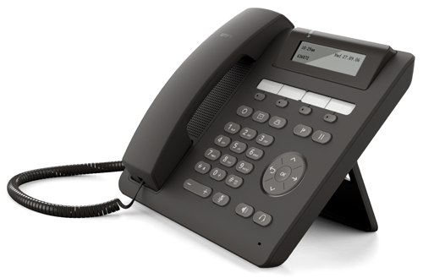
OpenScape Desk Phone CP200

#
OpenScape Desk Phone CP200

#

#

